**University of Prishtina “Hasan Prishtina”**

**Faculty of Electrical and Computer Engineering**



**Project documentation**

**Subject: Semantic Web**

**Project title: Boxing Ontology**

**Professor/Assistant name Name & surname / email address of students**

Prof. Dr. Lule AHMEDI 1. Uran Lajçi [uran.lajci@student.uni-pr.edu](mailto:uran.lajci@student.uni-pr.edu)

Msc. Adrian YMERI 2. Elvir Misni [elvir.misini@student.uni-pr.edu](mailto:elvir.misini@student.uni-pr.edu)

**Content**

1. Introduction 4

2. Problem Statement 4

3. Scope of the Project 5

4. Data used in the Project 5

5. The ontology of the domain 6

5.1. Classes 6

5.2. Properties 6

5.3. Relations 8

5.4. Data Hiearchy in Protege 9

6. Population of the domain ontology with data 11

7. SPARQL queries 13

8. SWRL rules 14

Protege 15

References 16

**List of Figures**

Figure 1. Class Hierarchy 9

Figure 2. Individuals by Class 9

Figure 3. Data Properties 10

Figure 4. Object Properties 10

**List of Abbreviations**

OWL – Web Ontology Language

SPARQL – SPARQL Protocol and RDF Query Language

SWRL – Semantic Web Rule Language

# 1. Introduction

The Semantic Web is a vision for the future of the World Wide Web, which aims to transform it into a global platform for data integration, sharing, and reuse. According to Berners-Lee [1], the Semantic Web is "an extension of the current web in which information is given well-defined meaning, better enabling computers and people to work in cooperation."

At the heart of the Semantic Web is the concept of ontology, which is defined as "a formal, explicit specification of a shared conceptualization" [2]. Ontologies provide a means for defining and sharing a common vocabulary and a shared understanding of a domain of knowledge, which can be used to annotate and classify data, and to reason about it in a more precise and automated way.

Ontologies are essential for enabling data interoperability and integration on the Semantic Web. According to McGuinness and van Harmelen [3], "ontologies are used to provide a common vocabulary for information exchange among agents, to enable reuse of domain knowledge, and to support intelligent reasoning about domain concepts."

The boxing ontology which we have build and explored in this project is an example of a domain-specific ontology, which is designed to capture the knowledge and concepts relevant to the sport of boxing. The objective of a boxing ontology is to provide a standardized and structured way of representing and sharing data related to boxing, such as the names of boxers, their weight classes, their rankings, their fight records, and their career trajectories.

One of the key benefits of the boxing ontology is that it enables data integration and sharing across different boxing-related applications and platforms. For example, it can be used to integrate data from different boxing databases, such as BoxRec and The Ring, to provide a more comprehensive and accurate picture of a boxer's career. It can also be used to create more personalized and engaging content for boxing fans, such as customized news feeds and social media updates.

In conclusion, the Semantic Web and ontologies are powerful tools for enabling more intelligent and connected web applications. By creating a boxing ontology, we can help to unlock the full potential of data in the sport of boxing, and to enhance the way that fans, analysts, and athletes engage with it.

# 2. Problem Statement

The lack of a standardized and structured way of representing and sharing data related to boxing has led to challenges in data integration and sharing across different boxing-related applications and platforms. The development of a boxing ontology aims to address this problem by providing a common vocabulary and a shared understanding of the domain of boxing.

# 3. Scope of the Project

The scope of the boxing ontology project is to create a domain-specific ontology that captures the knowledge and concepts relevant to the sport of boxing. The ontology will include entities such as boxers, weight classes, rankings, fight records, and career trajectories, as well as relationships between these entities. The goal is to provide a standardized and structured way of representing and sharing data related to boxing, which can be used to enhance the way that fans, analysts, and athletes engage with the sport.

# 4. Data used in the Project

The data that we got from our fighters.csv and popular_matches.csv [7] and we generated some instances.

# 5. The ontology of the domain

## 5.1. Classes

* Boxer: a person who engages in the sport of boxing
* Referee: a person who officiates a boxing match
* Trainer: a person who trains a boxer
* Boxing organization: an entity that organizes and oversees boxing matches
* Boxing match: a competition between two boxers
* Boxing equipments: gear used by boxers during a match, such as gloves and a mouthguard
* Rounds: an entity that represents the different rounds that take place during a boxing match
* Judges: an entity that represents the officials who are responsible for scoring a boxing match
* Medical personnel: an entity that represents the medical professionals who are responsible for providing medical assistance during a boxing match

## 5.2. Properties

Boxer has

* first name
* last name
* weight class: the weight class that the boxer competes in
* record: the number of wins, losses, and draws that the boxer has in their career
* ko_rate: the percenet of time that the boxer has won games with ko
* age
* height
* country

Referee has

* first name
* last name
* number of games refereed
* rank: how good is the referee
* record: the number of wins, losses, and draws that the referee gave
* contry

Boxing equipment has

* type
* size

Trainer has

* first name
* last name
* skills for which he can train

Boxing organization has

* name
* current boxers?
* boxers history?

Boxing match has

* location
* winner
* date

Round has

* Number of rounds: the total number of rounds in the match
* Winner of each round: the boxer who was judged to have won each round
* Length of each round: the duration of each round
* Break between rounds: the length of the break between each round
* Scoring system: the system used to score each round (e.g. 10-poin must system)

Judge has

* First Name: the name of the judge
* Last Name
* Scorecard: the scores assigned by the judge for each round of the match
* Accuracy: the percentage of times the judge’s scorecaed matches the final decision of the match
* Experience: the number of matches the judge has scored

Medical personnel has

* Name: the name of the medical professional
* Contact information: the contact information for the professional or medical team?
* Equipment: the medical equipment that the professional or team brings to the match (e.g. medical bags, stretchers, AEDs)?
* Role: the specific role that the medical professional or team plays during the match (e.g. ringside physician, paramedic, or EMT)?

## 5.3. Relations

* Boxer competes in Boxing organization: a boxer may be affiliated with a specific organization
* Boxer has fought against another Boxer: This relation can be used to record the opponents that a boxer has faced in their career
* Boxing match involves Boxer: a boxer participates in a match
* Boxing match involves Referee: a referee officiates the match
* Boxing match involves Boxing equipment: boxers use equipment during the match?
* Boxing match involves Medical personnel: This relation can be used to record the medical personnel who are present at a match to provide medical attention if necessary?
* Boxing match has Rounds: This relation can be used to record the number of rounds in a match and which boxers won each round.
* Trainer trains Boxer in specific skills: a trainer work with a specific boxer to prepare them for matches
* Boxing organization sanctions Boxing match: This relation can be used to record which organization has sanctioned a particular match.
* Boxing match involves Judges: This relation can be used to record the judges who scored the match and their scores for each round
* Boxing equipment is regulated by Boxing organization: This relation can be used to record the regulations that the organization has for the use of boxing equipment in matches
* Boxer is ranked by Boxing organization: This relation can be used to record the current ranking of a boxer within their weight class, as determined by the organization

## 5.4. Data Hiearchy in Protege

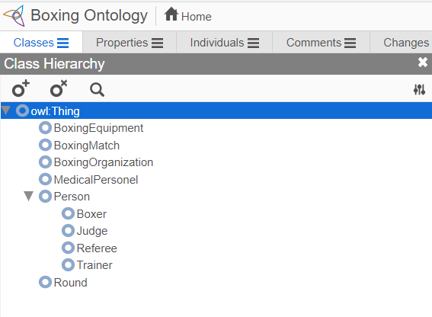

Figure 1. Class Hierarchy

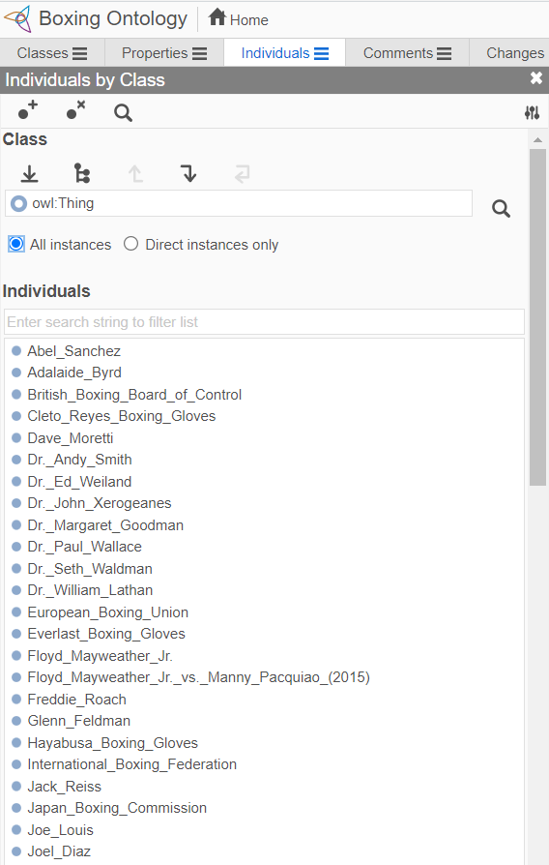

Figure 2. Individuals by Class

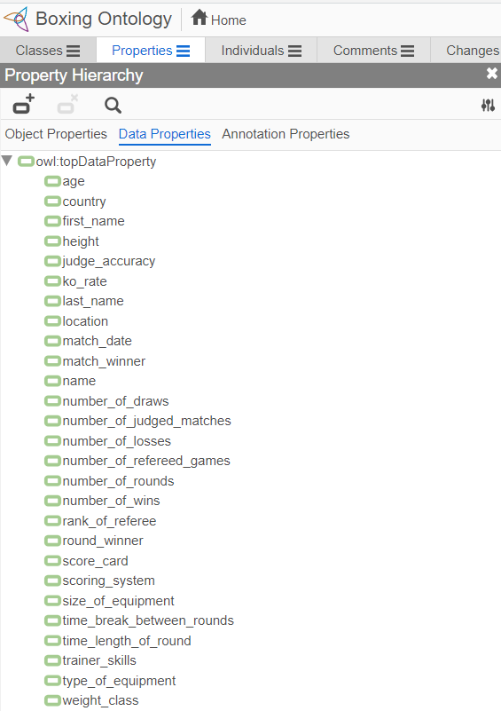

Figure 3. Data Properties

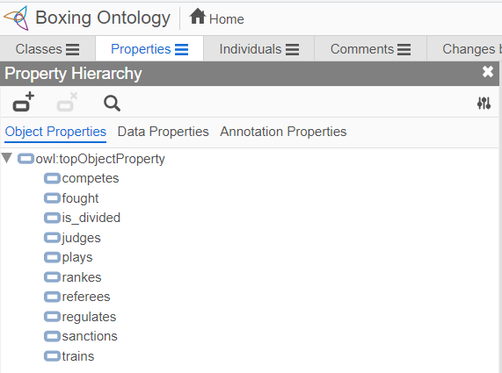

Figure 4. Object Properties

# 6. Population of the domain ontology with data

Boxer

* age (int)
* country (string)
* first_name (string)
* last_name (string)
* height (double)
* ko_rate (int)
* number_of_draws (in)
* number_of_losses (int)
* number_of_wins (int)
* weight class (string)

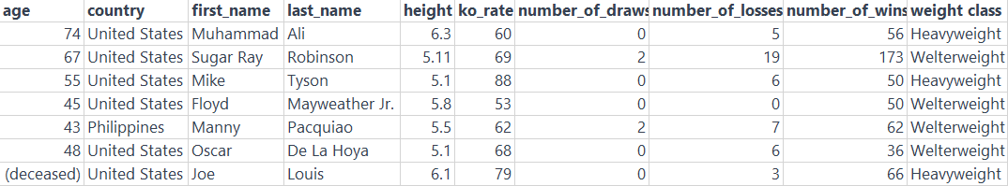

Referee

* age (int)
* country (string)
* first_name (string)
* last_name (string)
* number_of_draws (in)
* number_of_losses (int)
* number_of_wins (int)
* rank_of_referee (int)

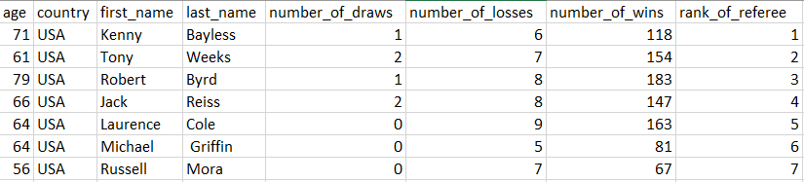

Trainer

* age (int)
* country (string)
* first_name (string)
* last_name (string)
* skills (string)

Boxing organization

* name (string)

Boxing match

* location (string)
* date (datetime)
* winner (string)

Boxing equipments

* size_of_equipment (double)
* type_of_equipment (string)

Rounds

* time_length_of_round (int)
* time_break_between_rounds (int)
* scoring_system (string)
* round_winner (string)
* number_of_rounds (int)

Judges

* age (int)
* country (string)
* first_name (string)
* last_name (string)
* score_card (int)
* number_of_judged_matches (int)
* accuracy (int)

Medical personnel

* name (string)

# 7. SPARQL queries

# 8. SWRL rules

# Protege

Protege is a free, open-source ontology editor and knowledge management system, widely used in both academia and industry for ontology development, management, and visualization. It provides a user-friendly interface for creating and editing ontologies, as well as powerful reasoning and visualization capabilities for working with large and complex knowledge graphs.

One of the key features of Protege is its support for the Web Ontology Language (OWL), which is a standard language for representing and sharing ontologies on the Semantic Web. Protege provides a range of tools for creating, editing, and validating OWL ontologies, as well as for importing and exporting ontologies in various formats.

Protege is highly extensible and customizable, with a large and active community of developers and users who have created many plugins and add-ons for extending its functionality. These include plugins for integrating Protege with other tools and platforms, for automating ontology development and maintenance tasks, and for visualizing and exploring ontologies in new and innovative ways.

Protege has been widely used in a variety of domains, including life sciences, biomedical research, e-commerce, and social media analysis. It has been the subject of numerous research papers, books, and tutorials, which attest to its popularity and usefulness as a tool for ontology development and management.

For example, a tutorial on ontology development with Protege can be found in the book "Semantic Web for the Working Ontologist" by Allemang and Hendler [4]. The book "Ontology Engineering with Ontology Design Patterns" by Gangemi [5] includes a case study on developing an ontology for the music domain using Protege. The official Protege website [6] provides documentation, tutorials, and forums for users and developers, as well as links to related resources and tools.

# References

[1] Berners-Lee, T., Hendler, J., & Lassila, O. (2001). The Semantic Web. Scientific American, 284(5), 34-43.

[2] Gruber, T. R. (1993). A translation approach to portable ontology specifications. Knowledge acquisition, 5(2), 199-220.

[3] McGuinness, D. L., & van Harmelen, F. (2004). OWL web ontology language overview. W3C recommendation, 10(10), 2004.

[4] Allemang, D., & Hendler, J. (2011). Semantic Web for the Working Ontologist: Effective Modeling in RDFS and OWL. Morgan Kaufmann.

[5] Gangemi, A., Presutti, V., & Navigli, R. (2012). Ontology Engineering with Ontology Design Patterns: Foundations and Applications. Springer.

[6] Protege. (n.d.). Home page. Retrieved March 28, 2023, from <https://protege.stanford.edu/>

[7] Boxing Matches Dataset, https://www.kaggle.com/datasets/iyadelwy/boxing-matches-dataset-predict-winner

# Biblography

[1] Simple Protege Introduction, Noureddin Sadawi

https://www.youtube.com/playlist?list=PLea0WJq13cnAfCC0azrCyquCN_tPelJN1

[2] Foundations of Semantic Web Technologies - Pascal Hitzler, Markus Krotzsch, Sebastian Rudolph